Day in the Life of the Hudson River 10/13/22
Hoboken Cove, NJ
RIVER MILE: 0.6
Salt Front: ~ RM 76
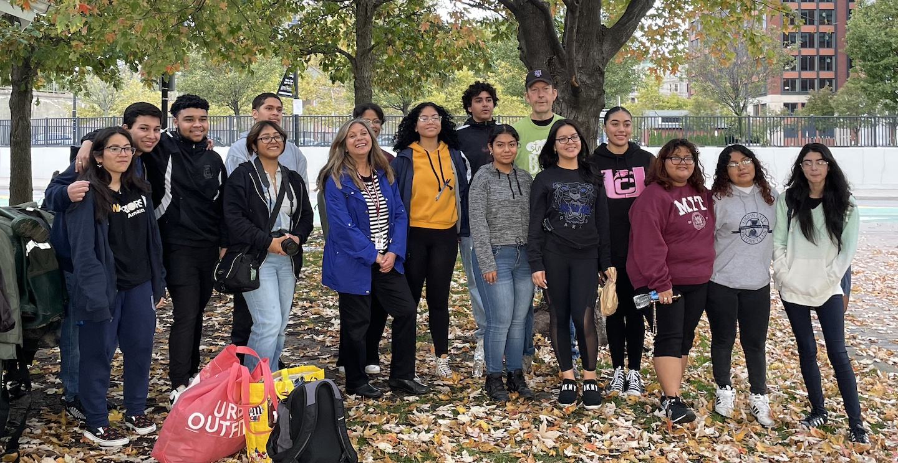
Resilience Adventures and Union City High School (11th grade)– Noelle Thurlow
14 students & 7 adults
Latitude 40.7484°N & Longitude – 74.0240°W
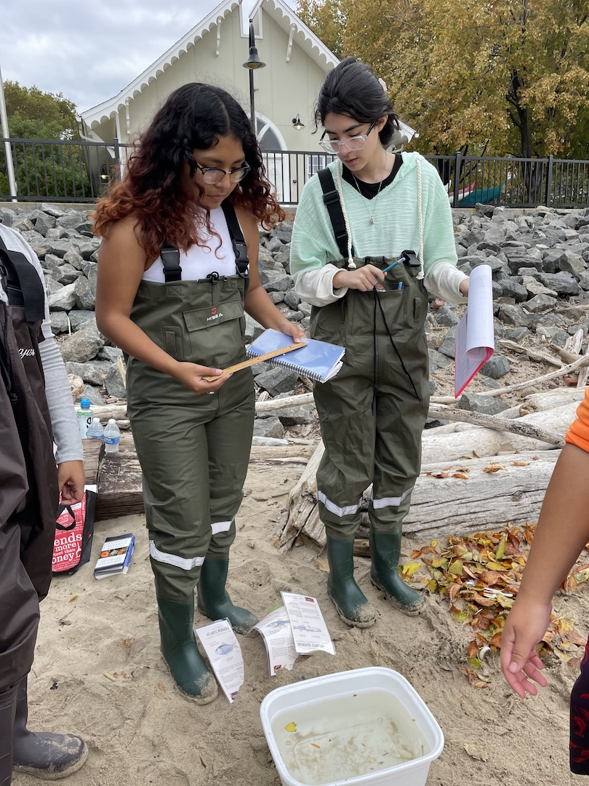 | 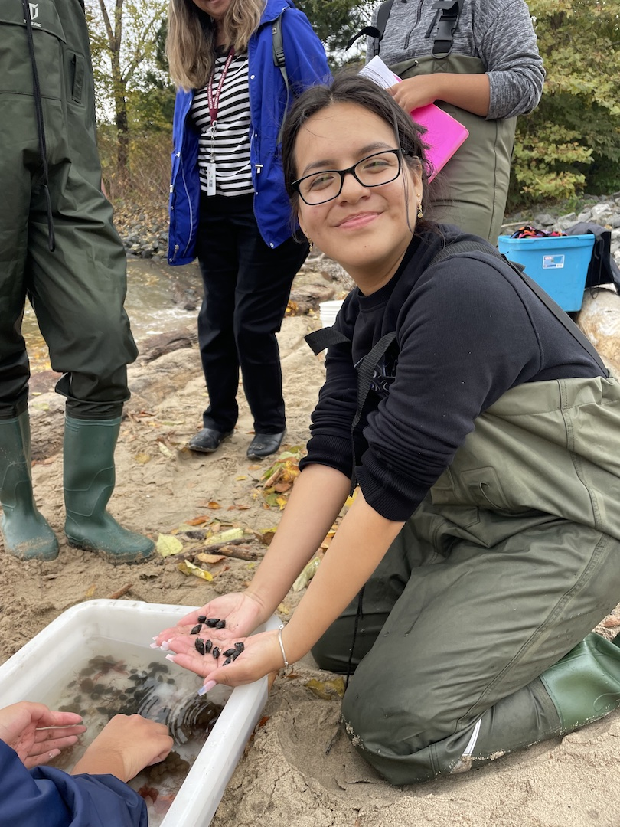 | 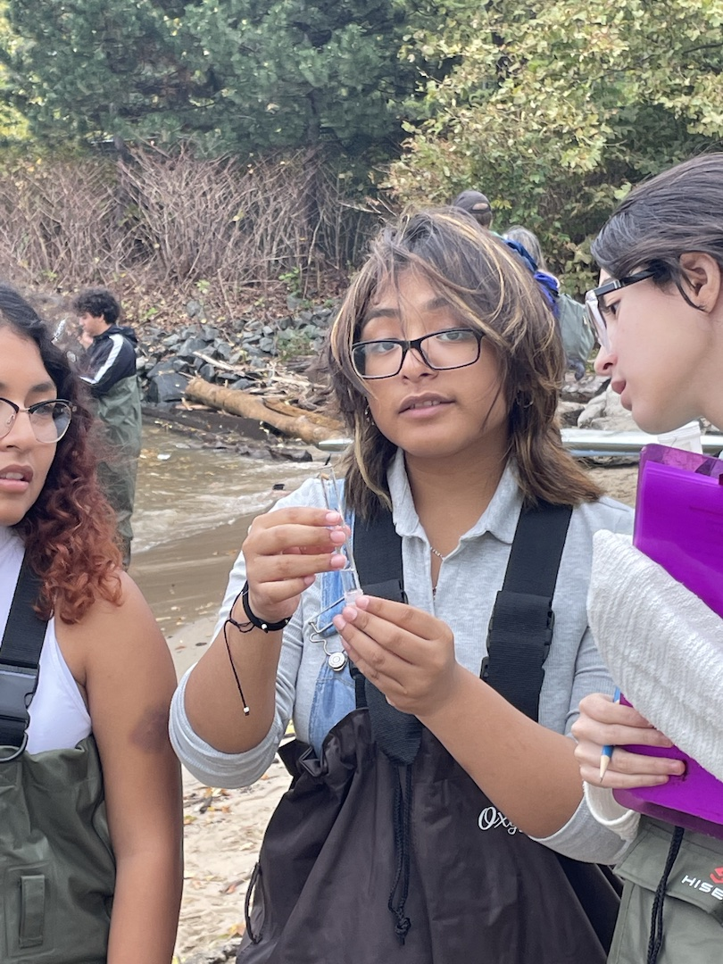 | 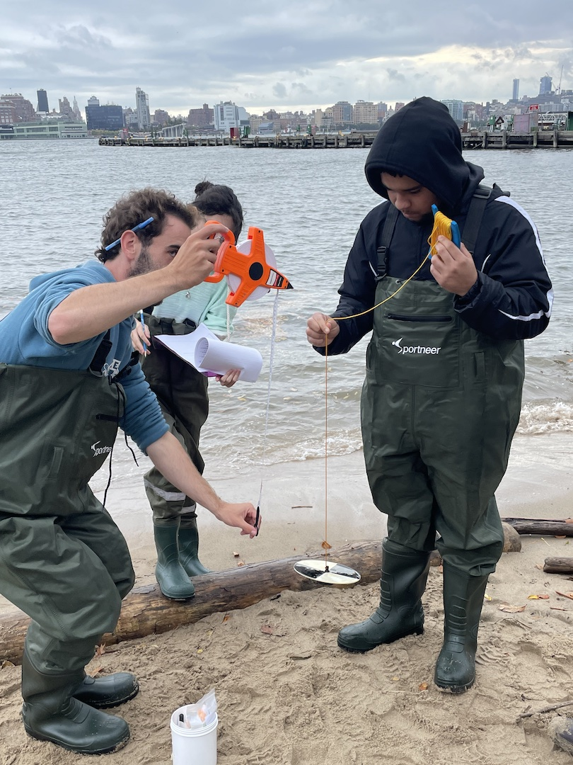

Location: Hoboken Cove, NJ
Area: The sandy section of the beach of Hoboken Cove
Surrounding Land Use: 90% Urban/Residential; 5% Forested; 5% Beach
Sampling Site: Pier, beach, wood bulkhead, RipRap (large rocks)
Shoreline: 30% Sandy; 70% Rocky
Water: Choppy
River Bottom: Muddy
Plants in area: 5% Sea Lettuce; 5% Sour Weeds
*NR = Not read/recorded
ITEM |  | Time |  | Reading |  |  |  | Comments
Physical
Air Temperature- |  | 9:45 AM  10:00 AM  11:00 AM |  | 19°C  19.5°C  20°C |  |  | 66°F  67°F  68°F
Wind Speed: |  | 11:00 AM |  | Anemometer  12 knots |  |  | Beaufort  4 | Direction  S/SE
Weather today |  | 9:45 AM |  | >75% cloud cover |  |  | Light intermittent drizzle
Weather the past 3 days: |  | Warm and sunny then became overcast on Wednesday
Tides- |  | Time |  | Rising, Falling, Unchanged |  |  | Water Height (cm)
 |  | 9:00 AM-10:00 AM  11:00 AM |  | Rising  Slack |  |  | NR
Current- |  | Time |  | Cm/sec |  | Knots | North/South | Ebb/Flood/Still
 |  | 8:00 AM  9:00 AM  10:00 AM  11:00 AM |  | NR |  | NR | NR | Flood  Flood  Flood  Flood/Still
Water Temperature- |  | 9:54 AM  10:33 AM  10:38 AM |  | 19°C  19°C  19°C |  |  | 65°F  65°F  65°F
Turbidity- Secchi Disk (cm) |  | 9:53 AM  10:34 AM |  | 46 cm  74 cm
Chemical
Salinity-Hydrometer |  | 10:00 AM  10:01 AM  10:02 AM  10:50 AM |  | 18 ppt  20 ppt  18 ppt  19 ppt
Standardized Salinity – Refractometer |  | 10:00 AM |  | 18,000 ppm
DO – Chemets Kit |  | Time  10:08 AM  10:11 AM  10:14 AM  10:52 AM |  | Temp  19°C  19°C  19°C  19°C |  |  | ppm DO  9 ppm  7 ppm  7 ppm  7 ppm | % saturation  95%  75%  75%  75%
pH – Color Match Kit |  | 10:24 AM  10:26 AM  10:28 AM |  | 7  7  7
Nitrates- |  | 10:44 AM |  | 5 ppm
Phosphates- |  | 10:41 AM |  | 1 ppm
Alkalinity- NR
Biological-
Fish – Seine Net, Crab Trap and Fish Trap, Hand Nets, Oyster Habitat Unit |  | Number |  | Name |  |  | Length of longest | Length of smallest
9:30-11:30 AM |  | 1  3 |  | *Oyster Toadfish  Atlantic Silverside |  |  | 25 cm  7.62 cm | *caught in seine  5.08 cm
Fish Totals |  | TOTAL:4 |  | Diversity: 2
Macroinvertebrates |  | Number |  | Name |  |  | Length of longest | Length of smallest
 |  | 100  90  200  3  3  1  1  8 |  | Sea Squirt  Eastern Mud Snail  Barnacles, Northern Rock  Isopods  Amphipod  Blue Crab (M)  Harris Mud Crab  Lacy Bryozoan |  |  | 3 cm  2 cm  1 cm  0.5 cm  0.5 cm  20 cm  1 cm  5 cm | 0.5 cm  1.5 cm  0.5 cm  0.1 cm  0.1 cm  -  -  2 cm
Macroinvertebrate Totals |  | TOTAL: 406 |  | Diversity:8
Sediment Core -
Length | H2S smell |  | Oxid Top |  | Oil |  | Grain Size | Other Features
26 cm | No |  | No |  | No |  | Abundant: sand  Common: mud  Rare: clay, gravel | Common: shells, macroinvertebrates  Rare: leaves, wood, living vegetation, brick
Boats-
 | Time |  | Name |  | Color |  | North/Southbound | Light/Loaded
Commercial | 9:46 AM  9:47 AM  9:54 AM |  | Queen Ann  Frank Sinatra  NYC Police Boat |  | Green  Yellow/ White  NR |  | Southbound  Northbound  Northbound | Loaded  Loaded  NR
Recreational-N/A

